Topic: Signal Processing with Convolutional Neural Networks to Reduce Noise v1
In recent years, there has been a mass emergence of more sophisticated and effective neural net architectures that have made the performance of Convolutional Neural Network to become even better than all the other traditional approaches to image processing. This sophistication has led to a new line of thought in terms of computer vision. Many scholars in the area of computers are beginning to shift their focus to CNN and they now believe that CNN in the future trend in the sector (McCann, Jin, & Unser, 2017). Being a new line of thought and since it is just getting attention, there is a limited understanding of the empirical success. There are three mainstream approaches to this new area of focus which include the signal perspective, approximation perspective, and optimization perspective. It is a general understanding that approximation and optimization perspectives are of mathematical representations that are focused on analyzing neural nets’ statistical properties, but the signal perspective tried to address the issues around de-noising or noise reduction during signal processing (McCann et al., 2017).
The goal of the Project
This project is mainly aimed at understanding the concept of Convolution Neural Networks (CNN), signal processing and how noise can be reduced during signal processing. The main focus is on how Convolution Neural Networks (CNN) can be applied to signal processing to reduce the noise. Two major questions will be used to guide the project:
- How can CNN architectures be tuned to solve signal processing problems and computer vision applications issues?
- What is the role of pre-processing and training done on CNN in terms of noise reduction and signal processing?
Objectives
- Come up with a novel CNN-based framework or technique that can be used to reduce impulse noise from images or signals.
- Conduct an overall mapping from noisy to noise-free signals by applying the 4-stage CNN architecture.
- Coming up with a mode of learning to offer training on the proposed CNN model (McCann et al., 2017).
Importance of Research
The project will help come up with a design and plan that can be used for testing the signal processing for the different systems or networks thus boosting the process and reducing the quality issues of the processed images, signals or files. The design of the signal processing techniques based on CNN can be later used to build a realizable trace that can be used to control and systemize files, raw data or important information. Technology is advancing significantly and there is a mass implementation or use of big data and as a result, there will be the need for signal processing technique that takes care of the processing speeds and that is smarter (Portsev, & Makarenko, 2018).
It is necessary to note that the proposed CNN model will adopt a computationally efficient transfer learning approach that will play a significant role in coming up with an effective end-to-end map that will lead from a noisy signal to a noise-free signal. Since most of Convolutional Neural Network has been used for image processing, there will be a need to look into a way of coming up with a noise-free image to help develop the concept or model that can be used for signals (Islam, Rahman, Ahmad, & Swamy, 2018).
Research Plan
The research plan includes a collection of data from different sources, a literature review of existing work on CNN and signal processing, recording, and comparison of the details from different literary works and a look into how CNN can be used for data processing and reduces the noise in the process. The work will also involve a look into real-time models that are used for signal processing and how these models can be integrated with CNN models to come up with one complete system for experimentation. A look into different signal processing algorithms, CNN algorithms and noise handling algorithms will play an important role in ensuring that a final framework that is based on relevant data is reached and a detailed summary of the findings done (McCann et al., 2017).
The figure below is a draft Gantt chart that outline some of the basic plan of the project as a whole. It is important to note that the chart is not a full representation of all that will be done. It is subject to improvement: 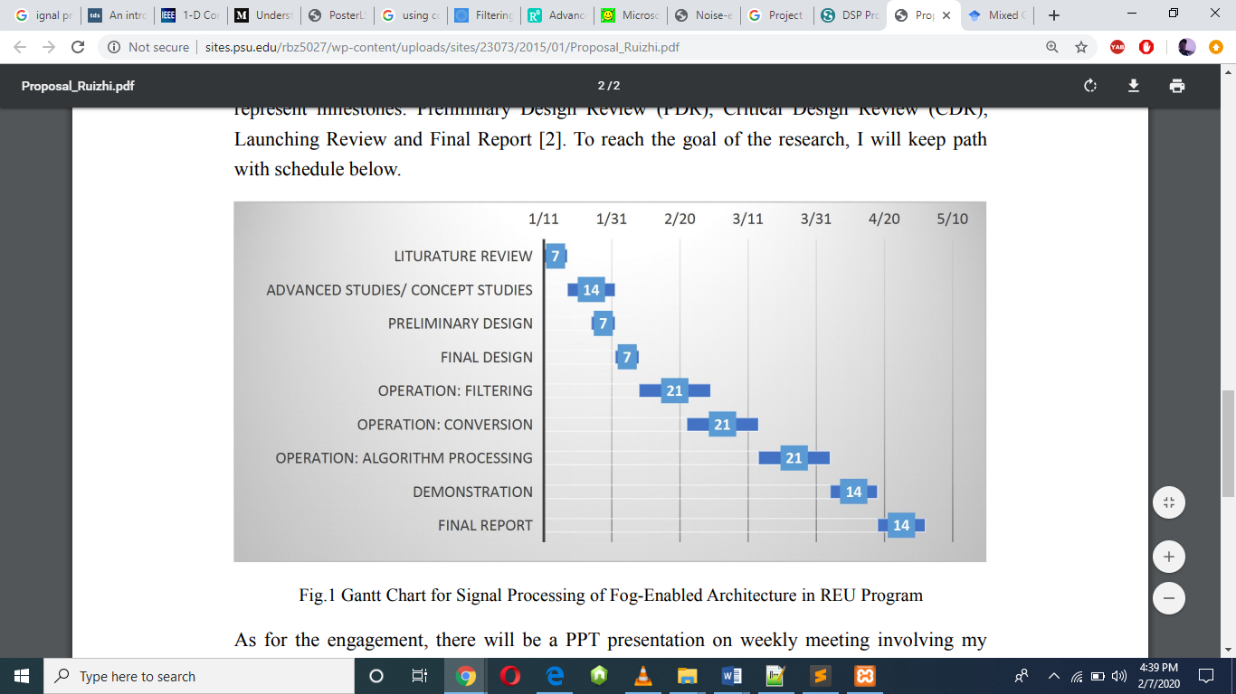

Expected Results
At the end of the research, the goals of the project are expected to have been attained. Some of the expected achievements include a design of a technical framework of signal processing that is based on a new algorithm that is based on Convolution Neural Network Model, an improvement of multiple applications of different kinds of signal processing operations across different platforms, and development of a learning-algorithm that would ensure that the proposed solution to the noise produced during signal processing is mastered effectively. A detailed report or a summary of the project has to be produced at the end of the project for presentation (Portsev, & Makarenko, 2018).

References
Islam, M. T., Rahman, S. M., Ahmad, M. O., & Swamy, M. N. S. (2018). Mixed Gaussian- impulse noise reduction from images using convolutional neural network. Signal Processing: Image Communication, 68, 26-41. https://www.sciencedirect.com/science/article/abs/pii/S0923596518300705
McCann, M. T., Jin, K. H., & Unser, M. (2017). Convolutional neural networks for inverse problems in imaging: A review. IEEE Signal Processing Magazine, 34(6), 85-95. https://ieeexplore.ieee.org/abstract/document/8103129/
Portsev, R. J., & Makarenko, A. V. (2018). Convolutional neural networks for noise signal recognition. In 2018 IEEE 28th International Workshop on Machine Learning for Signal Processing (MLSP)(pp. 1-6). IEEE. https://ieeexplore.ieee.org/document/8516920

